**San Francisco Bay University**

**Naim Rahman Ifti**

**ID: 20037**

**MATH201 - Calculus-I**

**Homework Assignment #2**

**Due day: 10/3/2024**

**Instruction:**

1. **Push the answer sheet to Github in word file**
2. **Overdue homework submission could not be accepted.**
3. **Takes academic honesty and integrity seriously (Zero Tolerance of Cheating & Plagiarism)**
4. Plot each following group of functions in one graph respectively by **Excel**, covering the appropriate domain of *x* and *y.*

Answer:

Group a is:

Group b is:

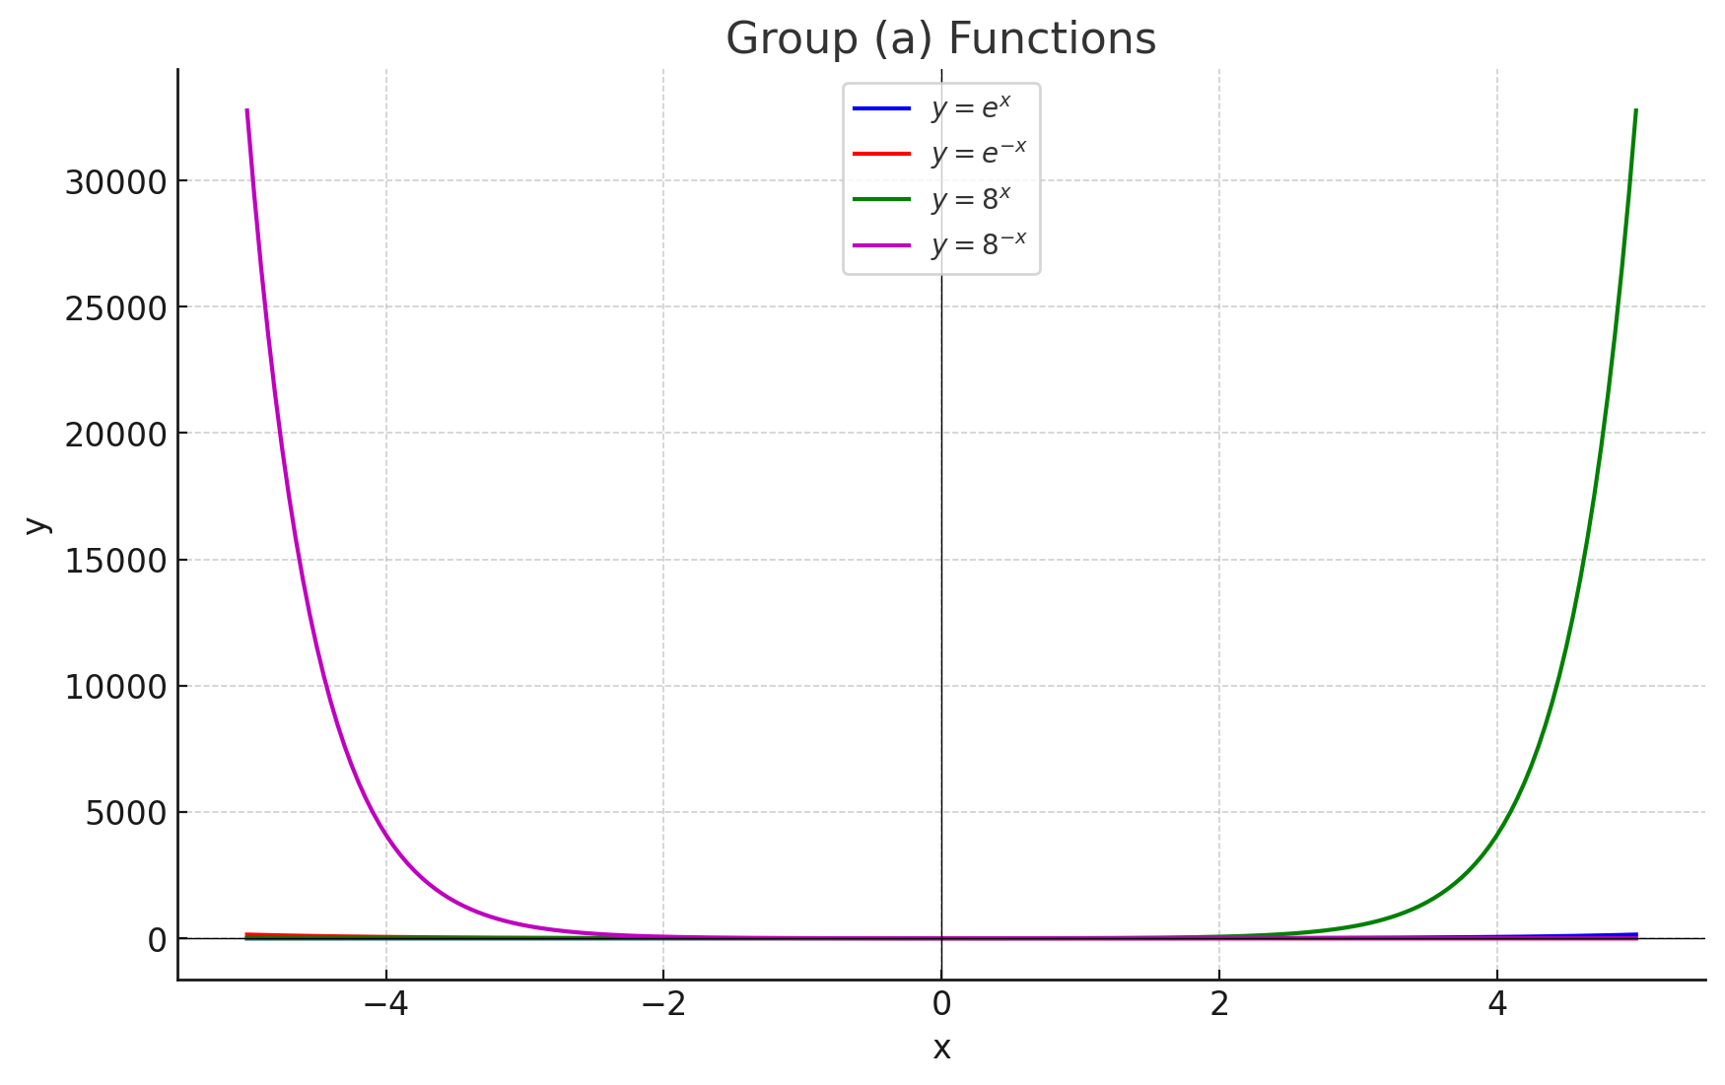

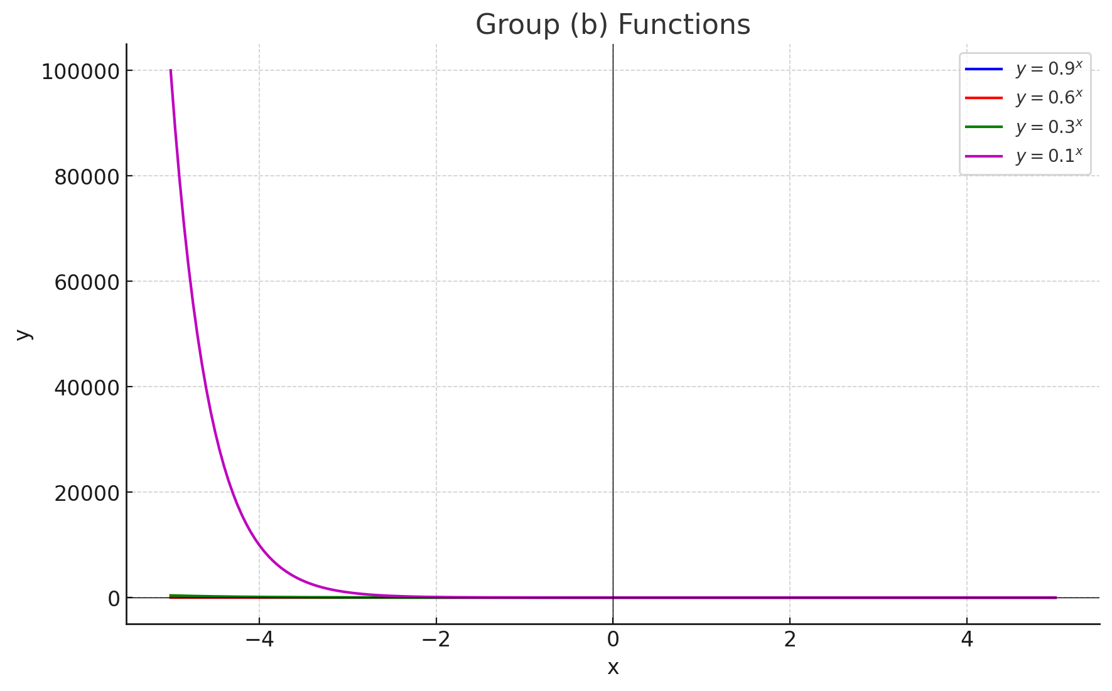

1. Given , prove that and verify it by the plot in **Excel.**

### Given:

f(x)= 10^x

To prove:

1. Difference Quotient for f(x)= 10^x

1. **Factor out 10^x**:

Thus, we have proven that:

In Excel plot:

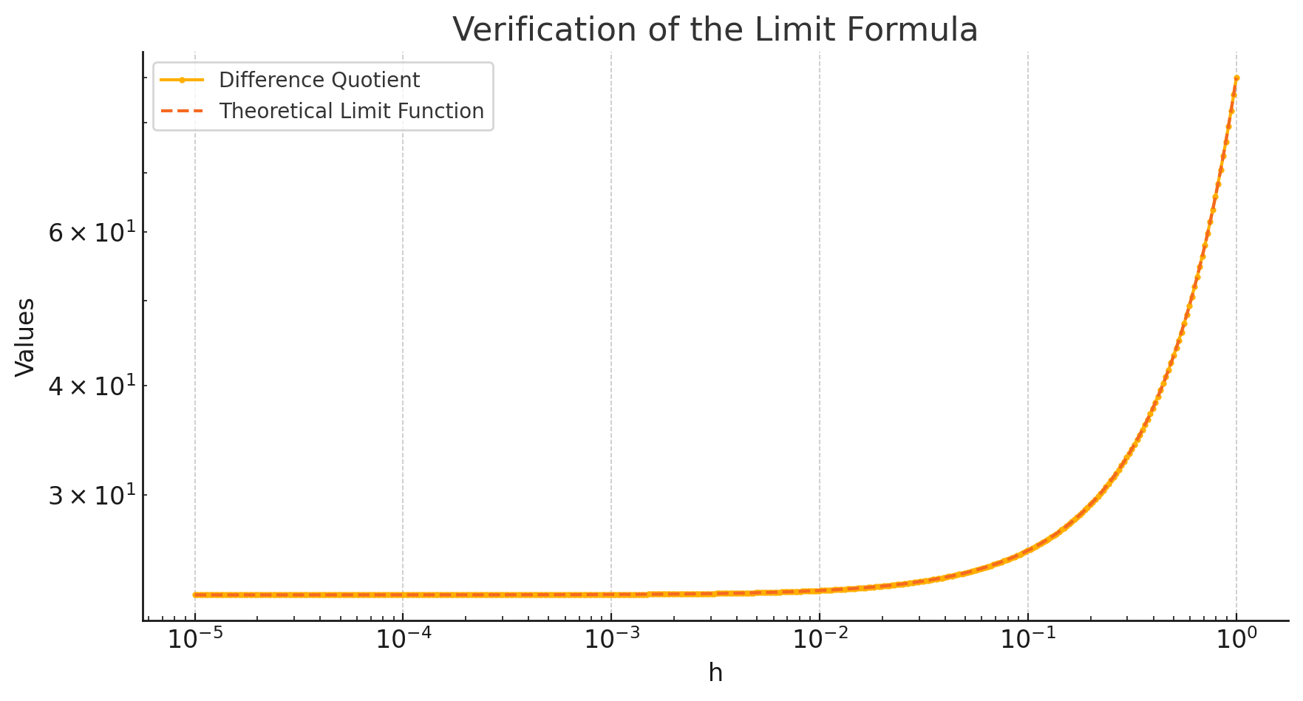

1. Compare the functions and by plotting curve in **Excel** and which function grows more rapidly when *x* is large? And prove it mathematically.

**Answer:**

Comparing the growth rates of f(x)=x5f(x) = x^5f(x)=x5 and g(x)=5xg(x) = 5^xg(x)=5x, let's examine the limit:

1. **First differentiation:**

1. **Apply L'Hopital's Rule again (second differentiation):**

**3. Continue applying L'Hopital's Rule (total five differentiations for the polynomial x^5):**

Thus, the limit simplifies to:

**In Excel:**

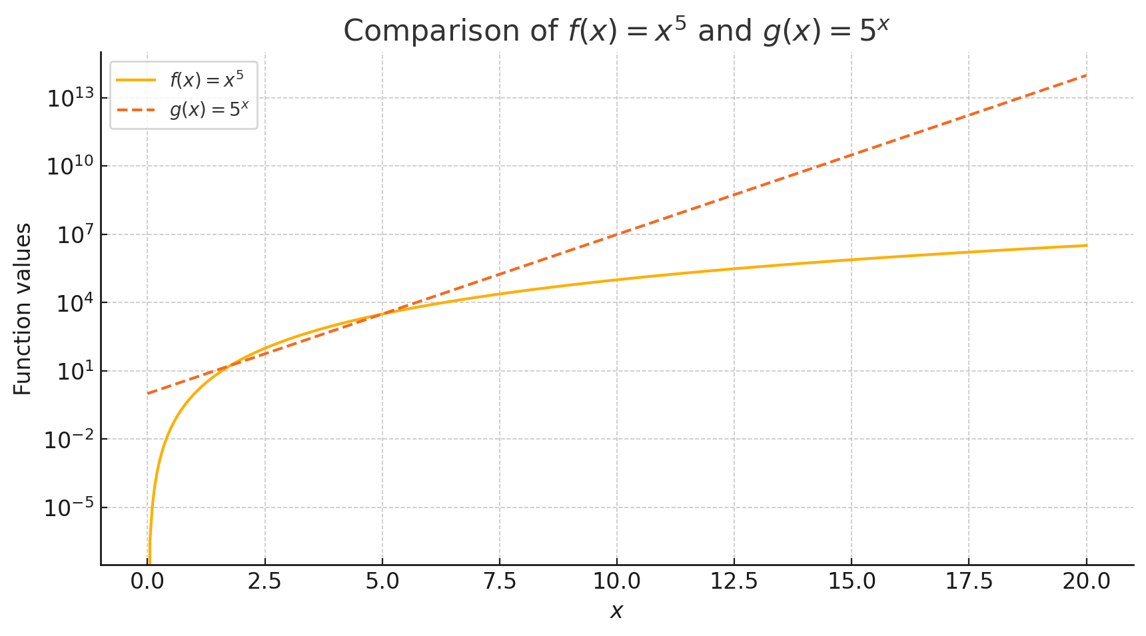

1. Plot the function in **Excel**. And then prove that is an odd function.

**

The plot of the function f(x)= {1 - e^{1/x}/{1 + e^{1/x}} ​ shows the characteristic symmetry about the origin, suggesting it is an odd function, as f(−x)=−f(x) appears to hold graphically.

To show f(x) is odd, we need to prove: f(−x)= −f(x)

f(x):

To show this equals −f(x), manipulate −f(x):

 

This confirms that: f(−x) = −f(x)

1. For the parametrized function
   1. where a > 0. How does the graph change when b changes by showing a group of curves by **Excel**?
   2. How does it change when *a* changes in **Excel**?

**Answer:**

**For the parametrized function** **:**

**a. How does the graph change when b changes by showing a group of curves?**

We need to observe how different values of b (with a constant) affect the shape of the curve. The function represents a logistic function, which exhibits an S-shaped curve. Changing b will affect the steepness of the curve.

**b. How does the graph change when a changes?**

Similarly, changing a (with b constant) will affect how the curve shifts along the y-axis. It affects the height and spread of the logistic curve.

Let's plot some graphs for different values of a and b to observe these changes.

* **Effect of varying b (with a=1)**: As the value of b increases, the slope of the curve becomes steeper. Higher b values make the transition from 0 to 1 faster.
* **Effect of varying a (with b=1)**: As a increases, the curve shifts vertically. Higher a values flatten the curve, making the rise from 0 to 1 slower.

1. If , find expression. And that, plot and in one graph by **Excel**

**Answer:**

### Finding the Inverse Function

To find g−1(x)), you first set y=g(x) and solve for x: y=x6 + x4 This equation is non-trivial to solve algebraically for x in terms of y, especially to find a closed-form expression. Given that it involves higher powers and is non-linear, numerical methods or graphing techniques are typically used to find x given y. However, for Excel plotting, we can approximate the inverse by calculating pairs of values.

### Plotting y=g(x)y = g(x)y=g(x) and y=g−1(x)y = g^{-1}(x)y=g−1(x)

1. **Prepare Values for g(x)**:
   * Calculate g(x) for x values ranging from 0 to a reasonable upper limit where the function values cover the range you are interested in. For instance, you might consider x from 0 to 2.
2. **Approximate g−1(x):**
   * Use the values obtained for g(x) to approximate the inverse by reversing the x and y pairs. This requires ensuring g(x) is strictly increasing or bijective in the range considered, which is true for g(x)=x6+x4 when x ≥ 0.
3. **Plot in Excel**:
   * Input x values in one column.
   * Compute y=g(x) in the next column.
   * List the corresponding g(x) values under a new x header and the original xxx values under a new y header to represent g−1(x).
   * Use Excel's graphing functionality to plot both sets of data on the same graph for comparison.

The plot shows:

* g(x) = x6 + x4 (blue curve).
* The identity function y = x (green dashed line).

1. When a camera flash goes off, the batteries immediately begin to recharge the flash’s capacitor, which stores electric charge given by

(The maximum charge capacity is and t is measured in seconds.)

* 1. Find the inverse of this function and explain its meaning.
  2. How long does it take to recharge the capacitor to 90% of capacity if a = 2 showing in the plot by **Excel**?

**Answer:**

**a.**

The goal is to find the inverse of Q(t) to express time ttt in terms of the charge Q. Let's solve the given equation for t:

To solve for t:

b.

To determine how long it takes to reach 90% of the maximum charge capacity (Q=0.9​) when a = 2, we use the inverse formula:

Substituting Q=0.9​ and a = 2:



The time required to recharge the capacitor to 90% of its maximum capacity is approximately t=4.61 seconds when a=2.

Here is the plot showing the capacitor charging over time:

* **Blue Line**: This is the function Q(t)=Q0(1−e^−t/a), representing the charge level over time.
* **Red Dashed Line**: This line represents 90% of the maximum charge capacity (Q0).
* **Green Dashed Line**: This vertical line indicates the time (t≈4.61seconds) needed for the capacitor to reach 90% of its capacity.